Performance Testing

Date | 31 june 2026
Team ID | LTVIP2026TMIDS24973
Project Name | Streamlining Ticket Assignment for Efficient Support Operations
Maximum Marks | 2 Marks

Model Performance Testing:

- Data Rendered:
The Operations Related table in ServiceNow is populated with multiple support tickets. These records include different issue types such as 'Unable to login', '404 Error', and 'Regarding Certificates'. This confirms that data is being recorded and rendered accurately in the system.
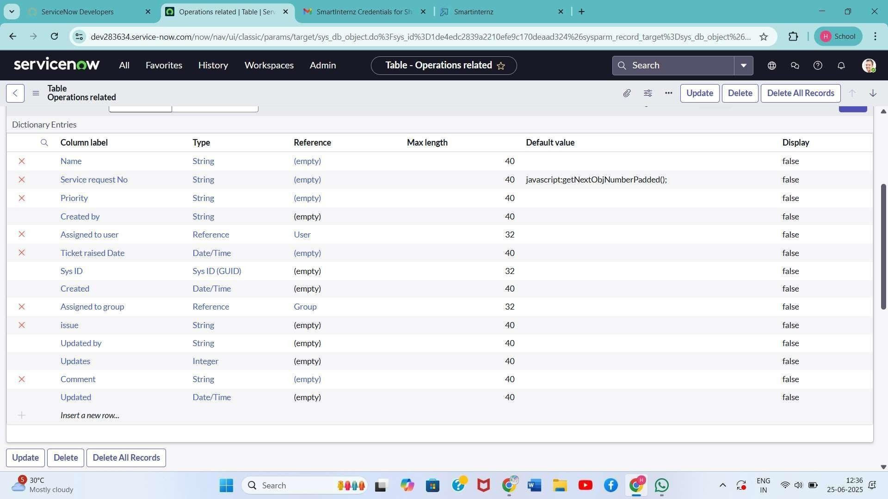

- Data Preprocessing:
Standardized issue types were configured using Form Design in ServiceNow. Predefined choices were added to the 'Issue' field to ensure consistent categorization and minimize input errors. This preprocessing supports accurate flow execution.
- Utilization of Filters:
Conditional logic was applied in Flow Designer to evaluate the issue type. Filters such as 'issue is Regarding Certificates' and 'issue is 404 Error' were used to guide flow actions. This allowed the system to dynamically route tickets to the appropriate support groups.
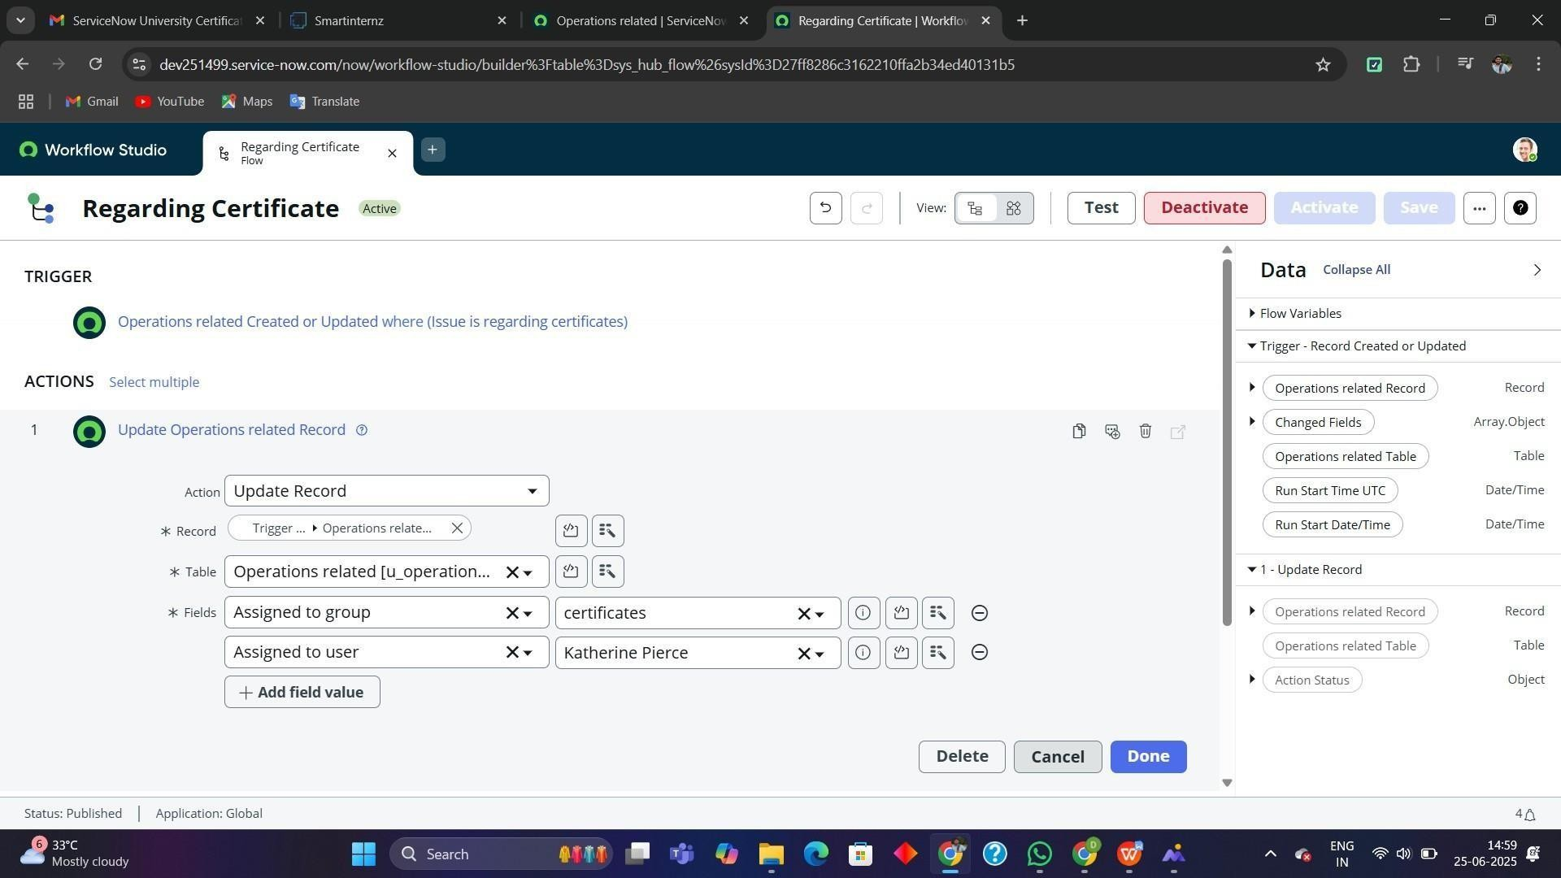

- No. of Visualizations / Graphs:
The dashboard included a total of 3 visual elements: a bar graph showing ticket count by group, a pie chart for issue distribution, and a line chart representing daily ticket
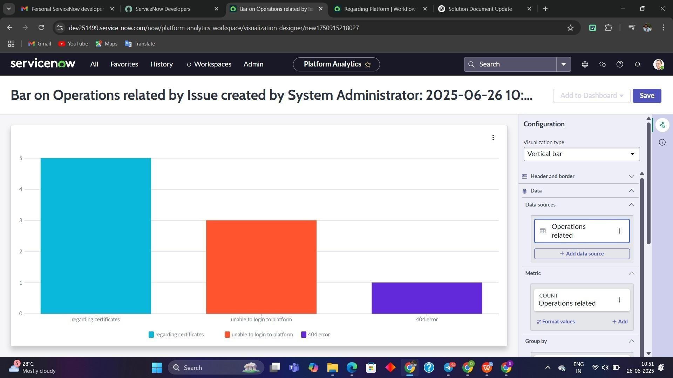

6. Story Design:
Two flows were designed in Flow Designer. One handled tickets with issues related to certificates, while the other addressed platform-related issues like login problems and 404 errors. Each flow included a trigger based on record creation or update, conditions to match specific issues, and actions to assign the ticket to the correct group. The flows were tested and successfully automated the ticket assignment process, improving operational efficiency.

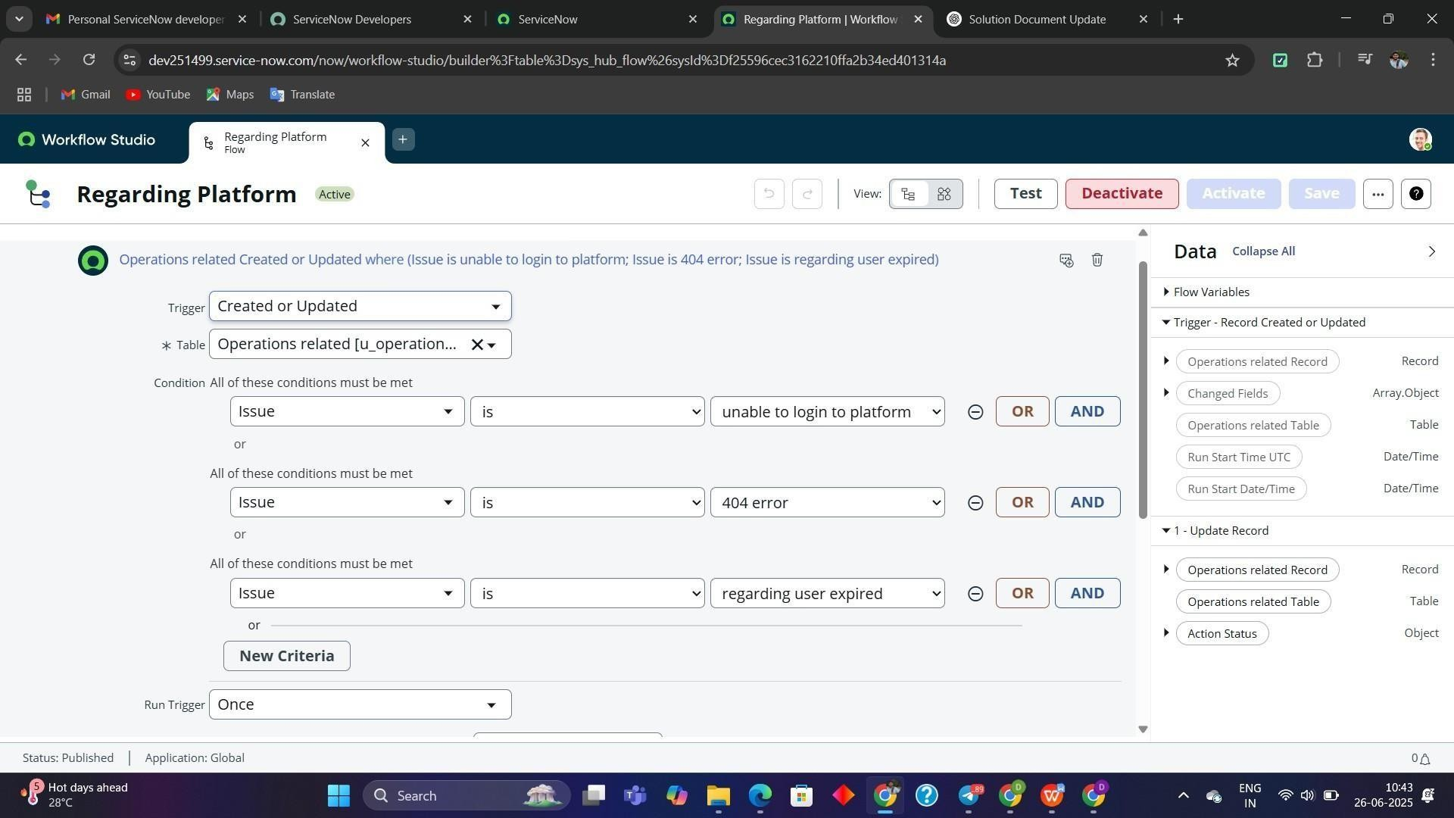

Results:
- All tickets assigned correctly based on issue
- Unauthorized users restricted from modifying sensitive data

- Groups receive only relevant tickets

